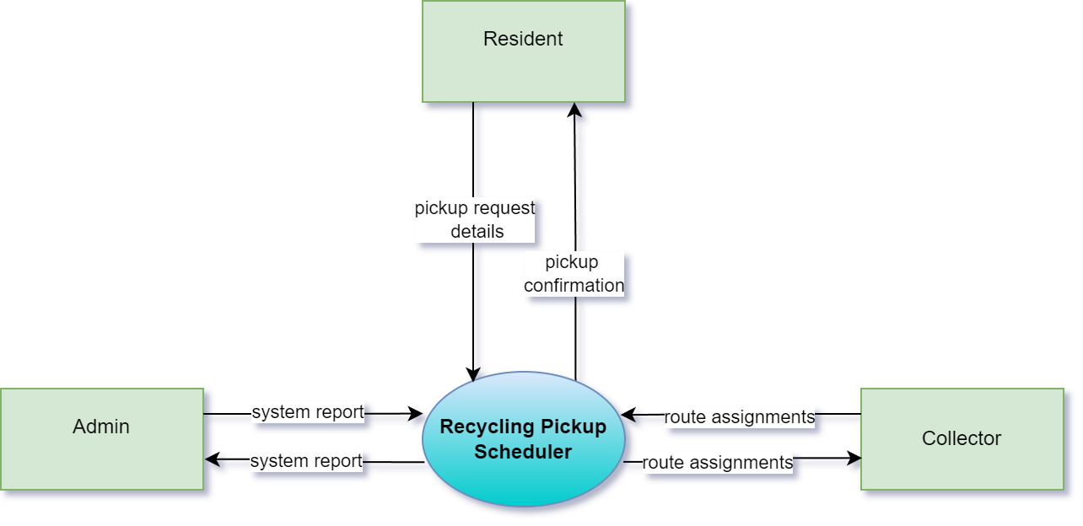
Recycling Pickup Scheduler context diagram
The Context Diagram provides a high-level overview of the Recycling Pickup Scheduler System and its interactions with external entities.
- External Entities:
  - Resident: Submits pickup requests and receives confirmation.
  - Admin: Receives system reports for monitoring and management.
  - Collector: Receives route assignments for pickups.
- System:
  - Recycling Pickup Scheduler: Processes requests, schedules pickups, assigns routes, and sends notifications.
- Data Flows:
  - Pickup request details: Sent from Resident to the system.
  - Pickup confirmation: Sent from the system to Resident.
  - System report: Sent from the system to Admin.
  - Route assignments: Sent from the system to Collector.
This diagram shows how the system interacts with external entities and helps outline its basic functions.

